KSBT -

Functionality
Activity prices are maintained for various cost centers. This transaction is used to view a list of activity price for various cost centers.

Scenario
This scenario shows how you can access the report with the calculated prices of all activity types from interval 1 to ZZZZZZ for cost centers from cost center group ‘1201’.
Requirements
Prices are existing for activity type cost center combination.

Menu Path | Accounting → Controlling → Cost Center Accounting → Information System → Information System → Reports for Cost Center Accounting → KSBT - Cost Centers: Activity Prices
Transaction Code | KSBT

1. Double click on KSBT - Cost Centers: Activity Prices.

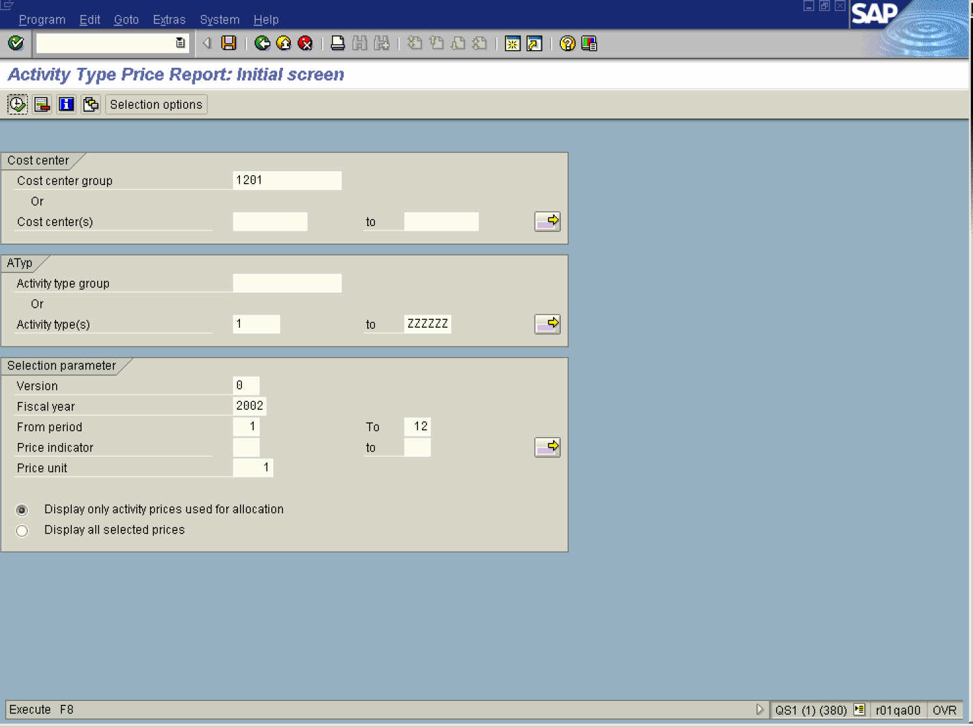

2. Update the following fields:

Field Name | Description | Values
Cost center group | Code identifying a grouping, for internal reporting purposes, of cost centers with similar characteristics | Example: 1201
Activity type: | Beginning of a range | Example: 1
Activity type: to | End of a range | Example: ZZZZZZ
Version | Planning version | Example: 0
Fiscal year | Year relevant for analysis | Example: 2002
From period | Beginning period of analysis | Example: 1
To | Last period of analysis | Example: 12

3. Click the Execute
Activity Type Price Report: Overview screen

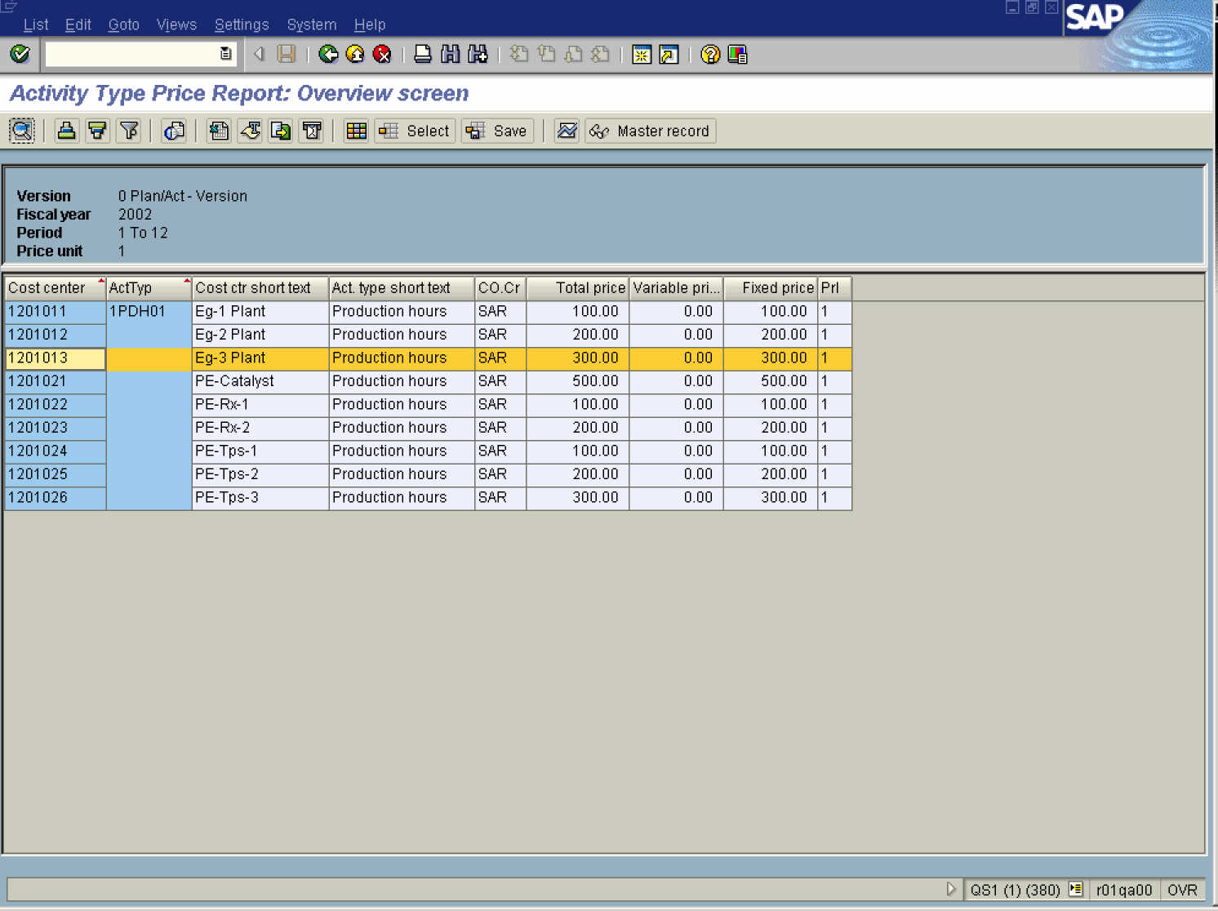

4. Select the line and click the Details button.

Details

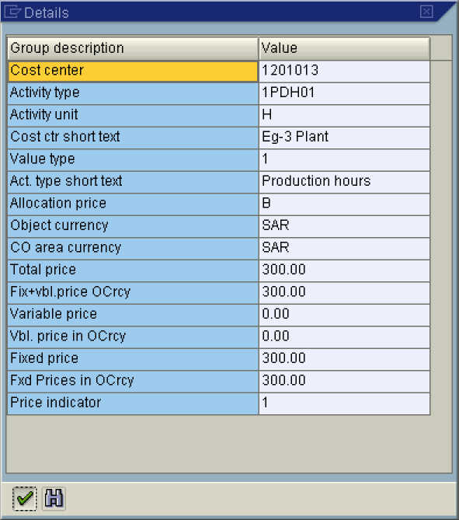

5. Click the Continue button.

Activity Type Price Report: Overview screen

6. Select the line and click the Period screen button.

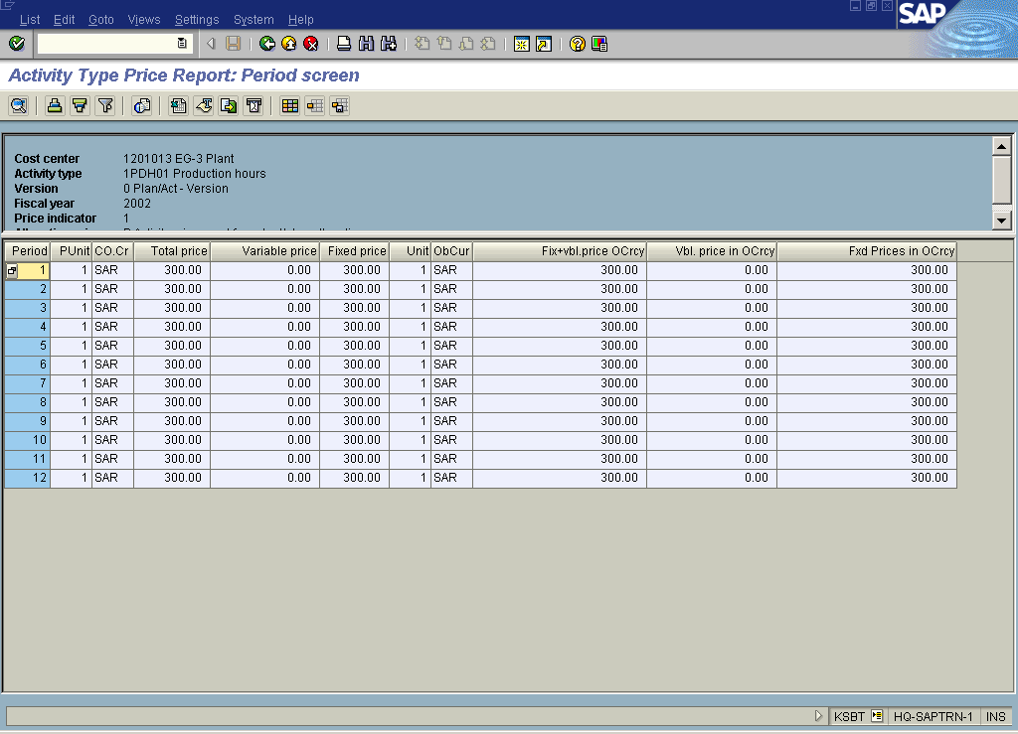

7. Click the Back button.

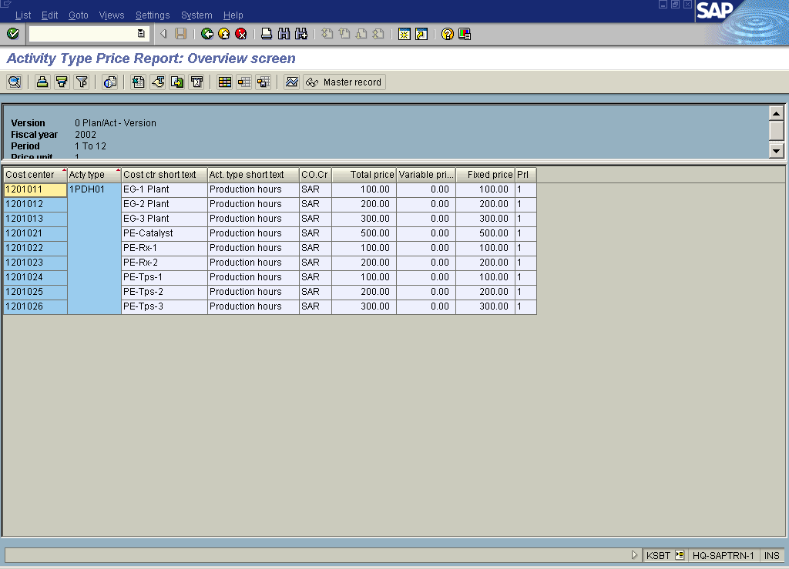

8. Click the Select layout button.

Choose layout

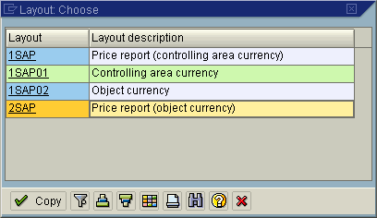

9. Click the 2SAP line to choose the layout.

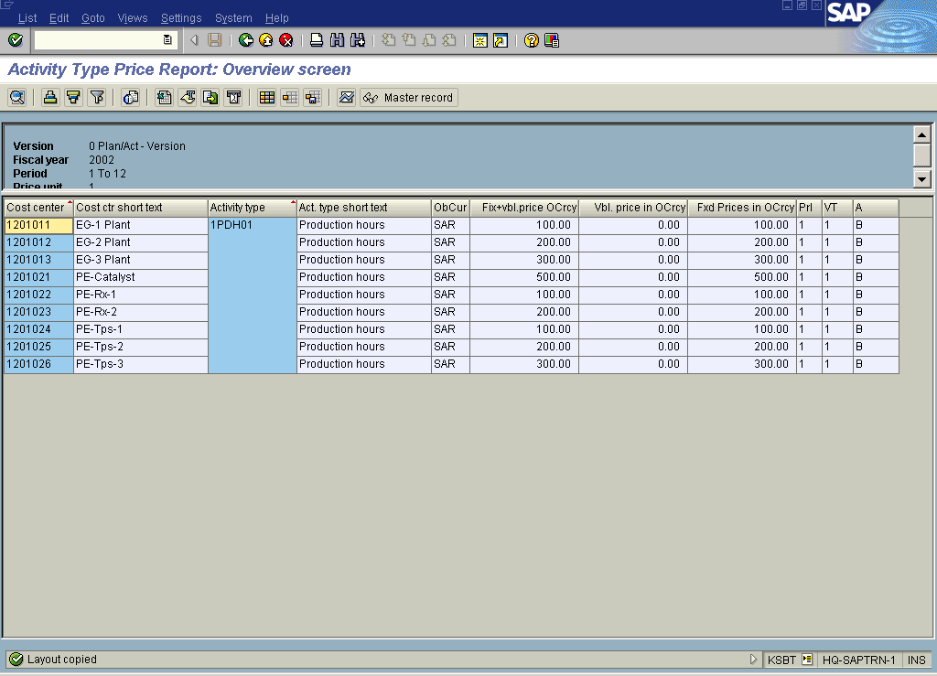

10. Click the Back button.

Exit list

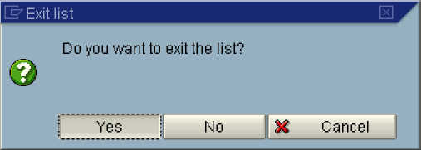

11. Click the Yes button.

12. Click the Back button to go back to SAP Easy Access screen.

